www.hestalbanssth.catholic.edu.au
Visual Arts Term 2
Please feel free to email me to ask any questions relating to your art
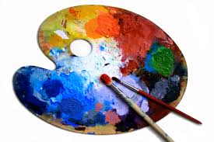
Mrs Hickey’s email is:
shobha.hickey@hestalbanssth.catholic.edu.au
GRADE 5 & 6
Week 4
ELEMENT OF LINE
A horse’s anatomy is widely used in art and represents an image of strength, power and majestic beauty.
You will decorate the inside of the horse with fancy line work you have learnt in the last two weeks. You can follow any of these tutorials below:
You will need:
A white sheet of paper a black marker coloured pencils for the background
Step by step
https://www.youtube.com/watch?v=5t4BJn4FuxY
https://www.youtube.com/watch?v=4UABkOrDTRU

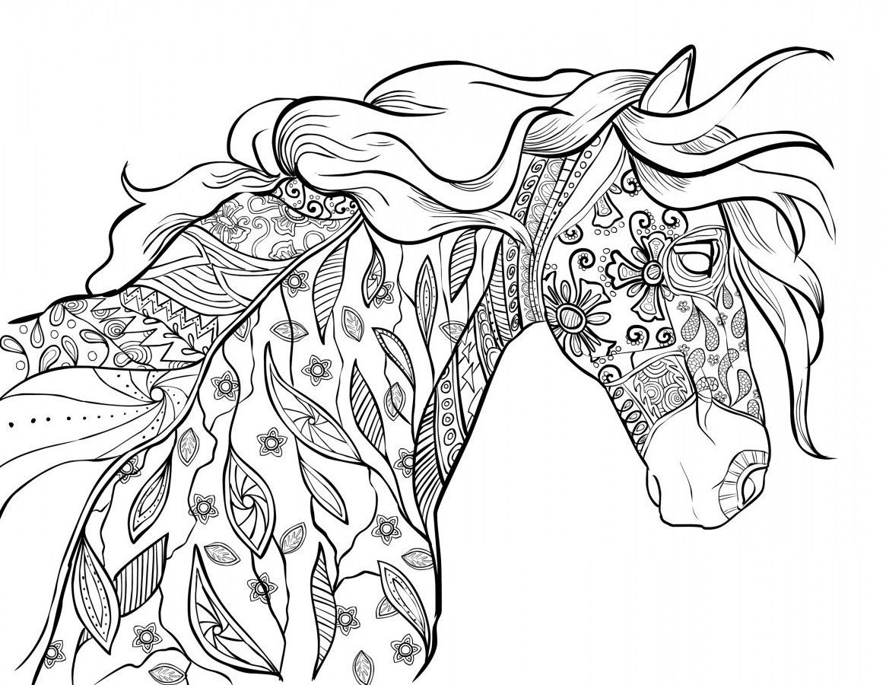

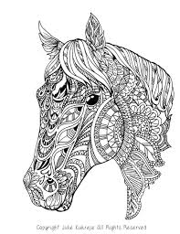
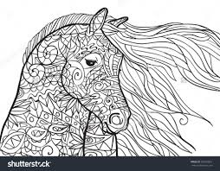
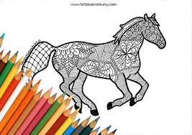

IDEAS OF LINE WORK
It is expected that you follow a tutorial.
If you are finding it hard, a worksheet has
been provided for you to draw fancy lines inside
an outline of a horse.

