Grade 4 Remote Learning Timetable- Week 2 Term 3
Once students are finished with their activities, please take a photo and submit it onto your own Google Classroom page between 3-3:15PM each day. We will be checking who is submitting their work.

 | Monday | Tuesday | Wednesday | Thursday | Friday
8:50- 9:00 | Good Morning  Google Meet with your class at 9.00am for the roll. We will explain the Home Learning Grid for the week. Please leave your mic on mute and listen to your teacher.  Google Meet Classroom Expectations  4KB -  4JK -  4JC - | Good Morning  Google Meet with your class at 9.00am for the roll. We will explain the Home Learning Grid for the week. Please leave your mic on mute and listen to your teacher.  Google Meet Classroom Expectations  4KB -  4JK -  4JC - | Good Morning  Google Meet with your class at 9.00am for the roll. We will explain the Home Learning Grid for the week. Please leave your mic on mute and listen to your teacher.  Google Meet Classroom Expectations  4KB -  4JK -  4JC - | Good Morning  Google Meet with your class at 9.00am for the roll. We will explain the Home Learning Grid for the week. Please leave your mic on mute and listen to your teacher.  Google Meet Classroom Expectations  4KB -  4JK -  4JC - | Good Morning  Google Meet with your class at 9.00am for the roll. We will explain the Home Learning Grid for the week. Please leave your mic on mute and listen to your teacher.  Google Meet Classroom Expectations  4KB -  4JK -  4JC -
9:00-10:00 | Reading  WALT: to read and identify the features of a multimodal text [informative text].  WILF: title, subheadings, images, captions, fact boxes, glossary  Brainstorm: what do you know about multimodal texts?  Read ‘Healthy Living’ Information Report from ‘Pearson English Magazine: Healthy Living by Rohan Clifford (p. 2) and (p.3).  Write down all the features of the structure of an information text.  YOUR TEACHER WILL UPLOAD THIS ON GOOGLE CLASSROOM  Punctuation & Grammar - it’s and its  Collect ‘It’s and Its’ sheet. Write down the sentence and identify if you need it’s - it is or its. | Maths  Location Post Assessment Map work  Choose a location of your choice that you would like to put on a map. Remember it is to be a birds eye view of the location.  You may choose:  - Amusement Park  - Zoo  - Your bedroom  - School  - An island  - Mysterious destination  Be creative!!  Activity  Design your map using this website. This will be used for your assessment.  Include a title, Key, compass and scale (optional) on your map.  You may need to put this on a separate document.  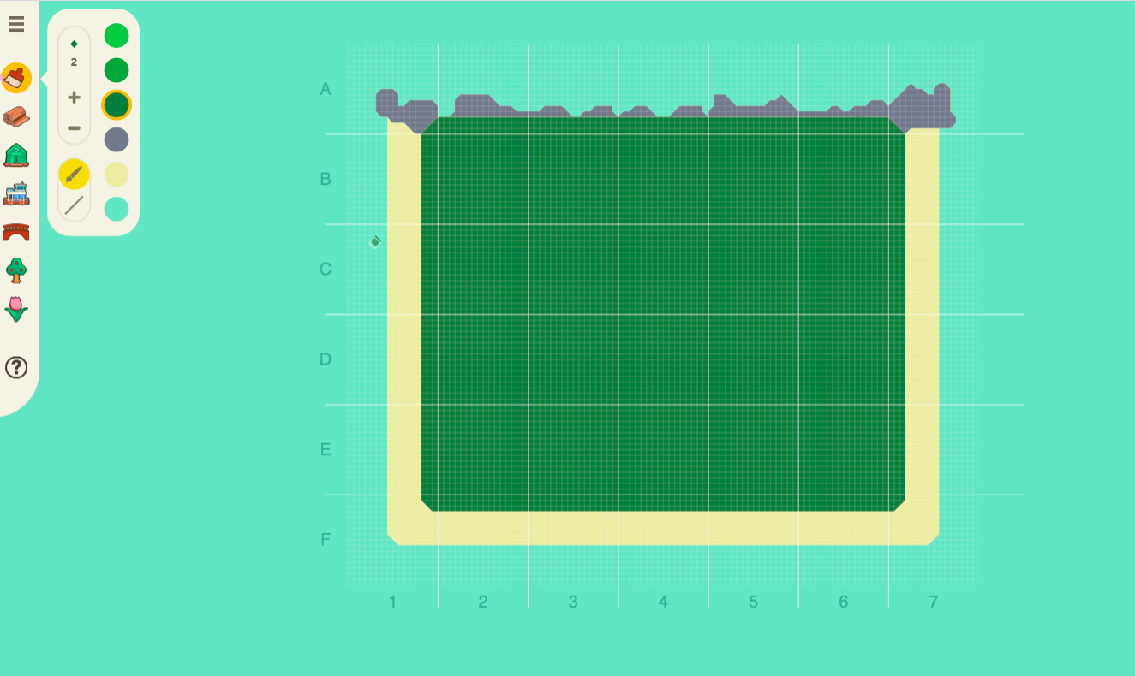 | Reading  WALT: to read and identify the features of a multimodal text [informative website].  WILF: title, subheadings, images, captions, fact boxes, glossary  Read ‘Traditional Food Sources ’Informative Website from ‘Pearson English Magazine: Healthy Living by Rohan Clifford (p. 12 and p. 13).  YOUR TEACHER WILL UPLOAD THIS ON GOOGLE CLASSROOM  Fact and Opinion  Identifying Fact or Opinion  Complete the ‘Identifying Fact or Opinion.’  Write your answers in your book in full sentences.  Identify why the statements are a fact or opinion and explain why. | Mass  Participate in the Mass from Wednesday’s Celebration  DAily Readings and Reflection https://catholic-daily-reflections.com/  After reading the reflection for Wednesday’s Reading answer the questions in full sentences in your book. | Maths  Location Post Assessment  Continue with your map design.  Screenshot a picture of your map. You will need to include these features:  - Legend  - Birds eye image of the location  - Coordinates  Your teacher will upload a question sheet that you need to complete answering questions based on your map.
10:00-11:00 | Writing  WALT: understand the characteristics of Information texts.  WILF:  What is an information text?  Activity:  Watch the Youtube video and list 10 different examples that are considered to be an information text.  Write down the definition of what nonfiction means in your own words.  Characteristics of NonFiction text  Your teacher will upload this document for you to edit on.  You need to rewrite on the document the correct order for the subheading in the boxes. | Reading  WALT: to read and identify the features of a multimodal text [informative website].  WILF: title, subheadings, images, captions, fact boxes, glassary  Read ‘Healthy Food Choices’ Information Report from ‘Pearson English Magazine: Healthy Living by Rohan Clifford (p. 4 and pg. 5).  YOUR TEACHER WILL UPLOAD THIS ON GOOGLE CLASSROOM  Activity after reading:  - Write down the features of information text that you notice.  - Write down 5 questions you have about the text. | Writing  WALT: understand the difference between fact or opinion.  WILF:  Fact or Opinion?  Students view the powerpoint and create a definition for fact and one for opinion.  They then explain the difference between the two and which one is more relevant to an information text and why. | LOTE  Check Google Classroom stream for activity. | Reading  WALT: identify the figurative language in a text and make connections to self  WILF:  Oh the places you’ll go You Tube video  Oh the places you’ll go slideshow and tasks  YOUR TEACHER WILL UPLOAD THIS ON GOOGLE CLASSROOM
11:00-12:00 | LUNCH/QUESTIONS WITH TEACHER  If you have any IMPORTANT questions about your tasks today please email me or request a google meet video with your teacher.  4KB -  4JK -  4JC | LUNCH/QUESTIONS WITH TEACHER  If you have any IMPORTANT questions about your tasks today please email me or request a google meet video with your teacher.  4KB -  4JK -  4JC | LUNCH/QUESTIONS WITH TEACHER  If you have any IMPORTANT questions about your tasks today please email me or request a google meet video with your teacher.  4KB -  4JK -  4JC - | LUNCH/QUESTIONS  If you have any IMPORTANT questions about your tasks today please email me or request a google meet video with your teacher.  4KB -  4JK -  4JC - | LUNCH/QUESTIONS  If you have any IMPORTANT questions about your tasks today please email me or request a google meet video with your teacher.  4KB -  4JK -  4JC -
12:00-12:20 | Independent Reading  Click on the link  https://www.getepic.com/  If you haven’t joined put down the class code then select your name. There are books that your teacher may have assigned for you. Please read that. Thanks.  4JC class code - yby1561  4JK class code - qsm3501  4KB class code -  hzs6238 | Independent Reading  Click on the link  https://www.getepic.com/  If you haven’t joined put down the class code then select your name. There are books that your teacher may have assigned for you. Please read that. Thanks.  4JC class code - yby1561  4JK class code - qsm3501  4KB class code -  hzs6238 | Independent Reading  Click on the link  https://www.getepic.com/  If you haven’t joined put down the class code then select your name. There are books that your teacher may have assigned for you. Please read that. Thanks.  4JC class code - yby1561  4JK class code - qsm3501  4KB class code -  hzs6238 | Independent Reading  Click on the link  https://www.getepic.com/  If you haven’t joined put down the class code then select your name. There are books that your teacher may have assigned for you. Please read that. Thanks.  4JC class code - yby1561  4JK class code - qsm3501  4KB class code -  hzs6238 | Independent Reading  Click on the link  https://www.getepic.com/  If you haven’t joined put down the class code then select your name. There are books that your teacher may have assigned for you. Please read that. Thanks.  4JC class code - yby1561  4JK class code - qsm3501  4KB class code -  hzs6238
12:20-1:10 | PE  (Mr. Herrera)  Google Meet at  12 20 pm till 12:35 pm 4JC  12:40 pm till 12:55 pm 4KB  12: 55 pm till 1:10 pm 4JK  Will meet using Google Classroom links that your teachers have provided you on Google classroom banners. | Music  Check Google Classroom stream for activity. |  | Writing  WALT: Label the structure of an information text.  WILF: Headings, facts  Developing Informative Writing Skills- Powerpoint Slide  Read through the powerpoint presentation on the structure of an information text.  Activity: The Moon Landing Slideshow  - Write down the structure of an information text into your book.  - Write down a short description for each heading using examples from ‘The Moon Landing’ slideshow. | Writing  WALT: Label the structure of an information text.  WILF: Headings, facts  Look over the structure of an information text from yesterday’s lesson.  Activity:  Complete the sorting activity on the moon landing on the document uploaded by your teacher.
Art

Check Google Classroom stream for activity.
1:15-2:00 | Maths  Location Post Assessment Map work  Choose a location of your choice that you would like to put on a map. Remember it is to be a birds eye view of the location.  You may choose:  - Amusement Park  - Zoo  - Your bedroom  - School  - An island  - Mysterious destination  Be creative!!  Activity  Design your map using this website. This will be used for your assessment.  Features to include on your map:  - Title  - Key/Legend  - Symbols of map’s features  - compass  - scale (optional) on your map.  You may need to put this on a separate document. | Inquiry  Session 0:  Provocation  Put up a document with 4 pictures related to healthy/unhealthy images.  YOUR TEACHER WILL UPLOAD THIS ON GOOGLE CLASSROOM.  Ask the students to answer the questions in regards to the images. These are on the document provided. | Religion  Using the document that we have uploaded onto Google Classroom identify which of these images are showing a positive relationship and which are showing a negative and explain Why and How using the following statements:  The picture of … is showing a positive relationship because...  The picture of … is showing a negative relationship because... | Highway Heroes  Students are to complete Home Activities Week 2.  Activity 1  Activity 2  Your teacher will upload onto your Google Classroom. | Digital Technologies  Click on the link below and select 5 of the activities to complete in this session.  Code
2:00-2:30 | BREAK | BREAK | BREAK | BREAK | BREAK
2:30-3:00 | Daily Exercise/Stretches  WILF: I am looking for students to exercise at their own pace while following the coach.  Watch the 5 minute move video and copy the exercises that are being shown. | Handwriting Practice  (Spelling words)  Words ending in /shun/ using ‘cian’  musician  politician  electrician  magician  mathematician  dietician  statistician  technician  clinician  beautician  Practise writing them twice using cursive letters. Place words in alphabetical order.  Put each word into a creative sentence. | Daily Exercise/Stretches  WILF: I am looking for students to follow the dance routine.  Partake in the Just Dance video and invite a sibling to join along. | Daily Exercise/Stretches  WILF: I am looking for students to go out and walk/run/bike ride/kick a ball with an adult.  I want students to spend at least 30 mins walking/ running (if you can run 30 mins) bike ride or kicking a ball with a partner.  OR  WILF: I am looking for students to listen to video instruction and have fun dancing.  Look for some dance video on Go Noodle YouTube channel:  https://www.youtube.com/user/GoNoodleGames | Mindfulness  Write 5 things you’re grateful for and draw a picture of how you’re feeling completing work from home.
3:00-3:15 | PACK UP/SUBMIT  Check in with the teacher and Submit/take photos of work on google classroom page.  If needed via google classroom | PACK UP/SUBMIT  Check in with the teacher and Submit/take photos of work on google classroom page.  If needed via google classroom | PACK UP/SUBMIT  Check in with the teacher and Submit/take photos of work on google classroom page.  If needed via google classroom | PACK UP/SUBMIT  Check in with the teacher and Submit/take photos of work on google classroom page.  If needed via google classroom | PACK UP/SUBMIT  Check in with the teacher and Submit/take photos of work on google classroom page.  If needed via google classroom

