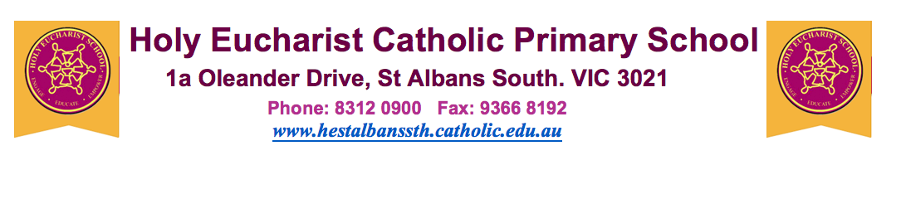
8th July, 2020.

Dear Parents, Guardians and Carers,

The Victorian Government has made some significant announcements about the introduction of new measures for schools across metropolitan Melbourne and Mitchell Shire to reduce the spread of coronavirus (COVID-19).

These include a change to arrangements for schools at the start of Term 3.

As our school is in an affected area, the government’s new measures will apply to us.

There will be five student-free days from Monday 13 to Friday 17 July for all of our students. Classes are expected to resume for these students on Monday 20 July 2020.

I know that this may mean uncertainty and another period of dislocation for you and your family. The school is doing everything it can to mitigate the impact of these changes on our community, and to minimise the impact of this disruption on your child’s learning journey.

If there are any changes to the arrangements for the start of Term 3, we will update you.

Yours sincerely,

Jeffrey Parker
(Principal)

