Colour the Technology
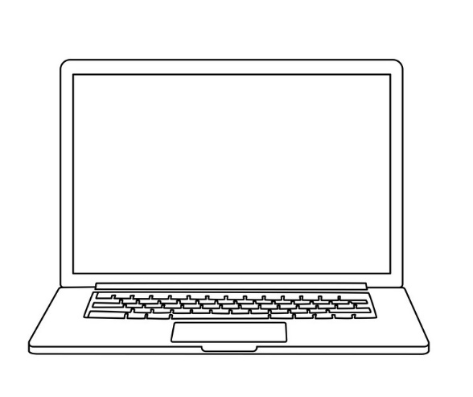 | 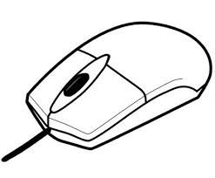
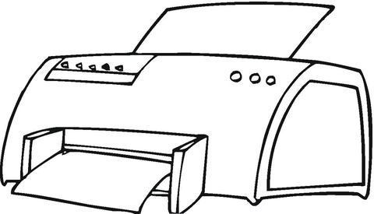 | 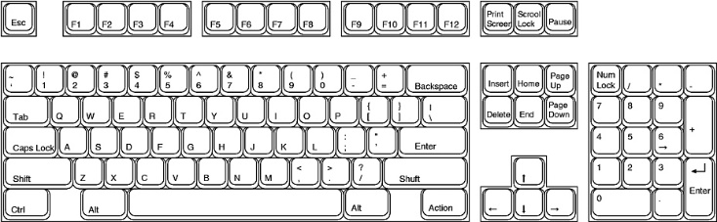
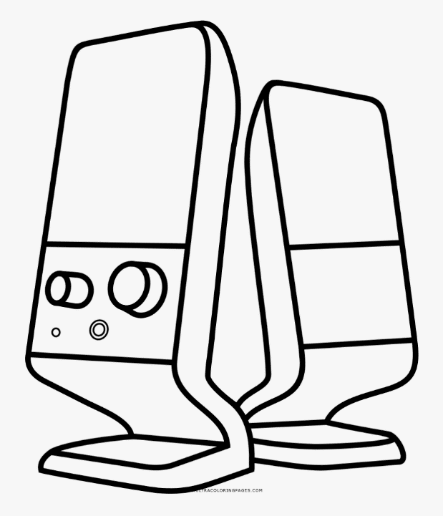 | 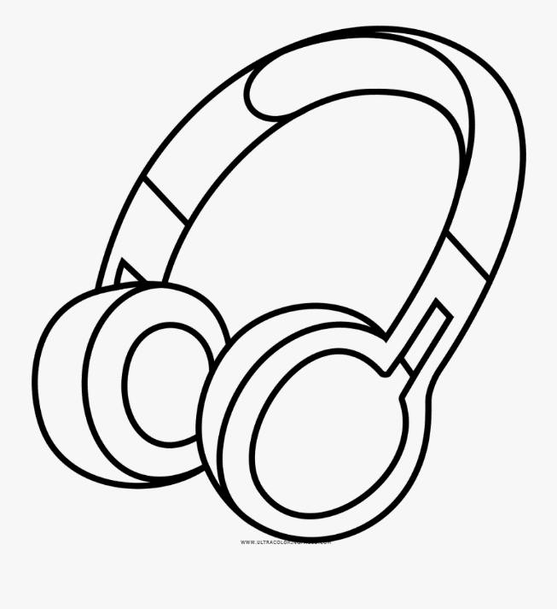

Colour the LAPTOP= RED  Colour the HEADPHONES= BLUE  Colour the SPEAKERS= YELLOW | Colour the PRINTER= GREEN  Colour the KEYBOARD= PURPLE  Colour the MOUSE= PINK

