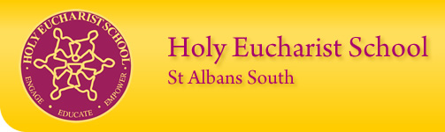

Newsletter – No. 15, 6th November 2020 English
www.hestalbanssth.catholic.edu.au

Holy Eucharist School
1a Oleander Drive,
St Albans, VIC 3021
Ph: 8312 0900 Fax 9366 8192
Acting Principal:
Mr. Michael Bonnici
principal@hestalbanssth.catholic.edu.au
Acting Deputy Principal:
Ms. Allison Borg
Holy Eucharist Parish
Parish Priest
Fr. Vincent Long Pham CSsR
Community Leader:
Fr Peter Ly Trong Danh CSsR
Assistant Priest:
Fr Vincensius Lolo CSsR
Fr Patrick Corbett CSsR
Fr Christoforus Matutina CSsR
(P) 9366 1310
Mass Times
Saturday: 6pm
Sunday: 9am, 10.30am, 6pm Vietnamese Mass at 12pm
Learning & Teaching
Michael Bonnici
Education in Faith:
Vanessa Shaw
Prep: Sharon Bonnici,
Mary James, Shalini Dos Santos & Bianca Gomez.
Grade 1: Tania Pufek, Mikaela Borg & Gwen Laughlin.
Grade 2 Julie Murnane, Jessica Kerlin, Thy Tran & Vivian Faraj
Grade 3: Natalie Kranjec,
Angela Lopez-Dee/Hania Borowik & Thilini Nanayakkara
Grade 4:, Jacelle Cablao, Jennifer Khong & Kathryn Barrie
Grade 5: Bruno Pellaschiar, Clare Christie & Adam Nicholl
Grade 6: Wally Antonowicz, Vanessa Shaw/Erin McNally & Tamara Patel
Learning Diversity/Wellbeing:
Julie Semcesen.
Family School Partnership /Wellbeing: Jo Dragovic
School Counsellor: Edward Faraci.
Library: Jenny Bistricki.
Digital Technology: Allison Borg.
Art: Shobha Hickey.
Music: Damian O’Bree.
Literacy Leader: Charise Gibbs
Intervention Leader: Hannah Power
Literacy Intervention: Jackie Dabal
Reading Recovery: Karen Colman
Maths Intervention: Anne Ablinger
Maths Leader P-6: Erin McNally
EAL/New Arrival: Irene Jurista
Physical Ed: Harry Herrera Education Support: Joe Sirianni
LOTE: Linda Hyunh & Miyi Sun
Business Manager: Sue Smart
Administration Staff:
Connie La Macchia, Mandy Huong & Rosemarie Slater.
Community Hub: Adella Howard
Cleaner: June Balatbat & Maria Attard
Maintenance: Barry Lynch
OSHP: Register on Camp Aust website

Thirty Second Sunday In Ordinary Time Year A
Matthew 25:1-13  A reading from the holy gospel according to Matthew  Look, the bridegroom comes. Go out to meet him.  Jesus told his disciples this story about the kingdom of heaven:  "The kingdom of heaven is like what happened one night  when ten girls took their oil lamps  and went to a wedding to meet the groom.  Five of the girls were foolish and five were wise.  The foolish ones took their lamps, but no extra oil.  The ones who were wise took along extra oil for their lamps.  "The groom was late arriving,  and the girls became drowsy and fell asleep.  Then in the middle of the night someone shouted,  'Here's the groom! Come to meet him!'  "When the girls got up and started getting their lamps ready,  the foolish ones said to the others, | 'Let us have some of your oil!  Our lamps are going out.'  "The girls who were wise answered,  'There's not enough oil for all of us!  Go and buy some for yourselves'  "While the foolish girls were on their way to get some oil,  the groom arrived.  The girls who were ready went into the wedding,  and the doors were closed  Later the other girls returned and shouted,  'Sir, Sir! Open the door for us!'  "But the groom replied, 'I don't even know you!'  "So, my disciples, always be ready!  You don't know the day or the time  when all this will happen."  The Gospel of the Lord.  Praise to you, Lord Jesus Christ.

Acting Principal’s Message
Dear Parents, Guardians and Carers,

Last Friday we celebrated World Teachers’ Day. The theme for this year was 'Teachers: leading in crisis, reimagining the future'. This theme reminds us of the commitment and dedication our teachers have shown particularly whilst teaching throughout the coronavirus (COVID-19) pandemic, both onsite and during remote learning.

On World Teachers Day we celebrated together as a school and we acknowledged our staff for their incredible contribution they have made to our school and the wider community. At Holy Eucharist we are so lucky to have dedicated, passionate and enthusiastic teachers who work tirelessly to care for your child and to ensure that they have every opportunity to achieve their full potential.

On behalf of the staff I would also like to thank all our families who have sent messages, emails and posted well wishes in recognition of this day. A big thank you also to the Huynh Family (Alisha 3NL and Emily 1MB) for providing pizzas and spoiling the staff with delicious macarons and to the Pham family (Mya 3TN and Kayden 6TP) for the yummy chocolates.

Recently we had a casual day to raise money for Catholic Mission as well as Red Day for Daniel. I would like to say a big thank you to all the parents and carers who supported these two very important charities. In total, we were able to raise over $1,480.00. Well done everyone!

Unfortunately, this year, we will not be able to host our annual Pre-Prep program for our new 2021 Preps due to the COVID-19 restrictions. However, the staff have been organising various remote activities in order to accommodate our new preps in transitioning to our school. I have also put together a ‘virtual tour’ of our Holy Eucharist so that our new and existing families are provided with information about our amazing school.

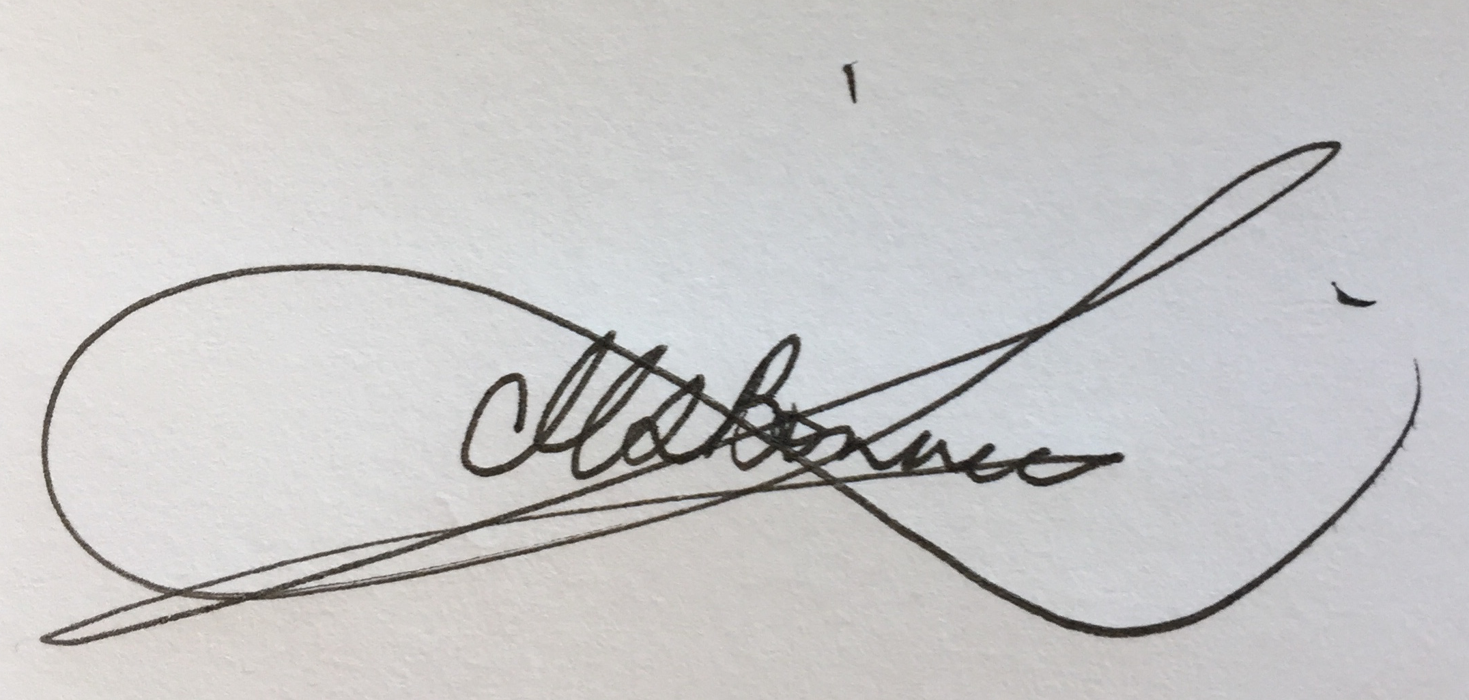
Finally, just a reminder that school photos will be taken on Monday 23rd November 2020. By then, all students should be wearing the correct school uniform and the school shoes.
Hope you all have a wonderful weekend. God Bless.

Mr Michael Bonnici
Acting Principal
michael.bonnici@hestalbanssth.catholic.edu.au

Administration News
Dear Parents,

Thank you to all our families, for your continued commitment to paying School Fees to Holy Eucharist School. The processing of fees since the children have returned has been amazing. As we are looking at our Re-Enrolment process to start next week, it would be greatly appreciated if families could finalise their school fees as soon as possible. Please, if any family is experiencing any financial concerns, please contact Connie on 8312 0900 so I can help develop a payment plan to reduce the strain on families at this time.
Mrs Sue Smart
Business Manager

Sat 7th /  Sun 8th Nov | Mon 9th Nov | Tues 10th Nov | Wed 11th Nov  Rememberance Day | Thurs 12th Nov | Friday 13th Nov | Sat 14th / Sun 15th  ^{Nov} | Monday 16th Nov
32nd Sundary in Ordinary Time  Year A |  |  |  | School Assembly 9.20am |  | 33rd Sunday in Ordinary Time  Year A

ACTING PRINCIPAL/ LEARNING AND TEACHING

The students will continue to have staggered starts and finishing times to minimise the risk of congregation at school entry and exit points. The students also have staggered breaks throughout the day.
Please also remember the 1.5 metre distance rule when lining up at the gates during drop off and pick up times. In the morning, the prep teachers will collect their student from the gate. However, all other classroom teachers will be in their rooms to let the students in. All classroom teachers will take the students to the gate at home time and will wait for students to be picked up. If you have more than one child at school, you can drop off and pick up your children from a preferred gate, so long as you have one child who belongs to the year level specified at the gate.

STARTING AND FINISHING TIMES

GRADE PREP (Gate 1 - Next to the hall)  GRADE 1 (Gate 2 - Next to the church)  GRADE 2 (Gate 4 - O’Brien Drive)  Gates open: 8:40am  Classrooms Open: 8:45am  Starting Time: 8:55am  Finishing time: 3:00pm | GRADE 3 (Gate 1 - Next to the hall)  GRADE 4 (Gate 2 - Next to the church)  GRADE 5 (Gate 4 - O’Brien Drive)  GRADE 6 (Gate 3 - Admin gate)  Classrooms Open: 9:00am  Starting Time: 9:10am  Finishing time: 3:15pm

STUDENTS WHO ARE UNWELL
Please remember that if your child is feeling unwell, please keep them at home. Students will be sent home if they present with symptoms such as a sore throat, temperature, tiredness, loss of taste or smell, tummy pains or shortness of breath. It is important that your emergency contact is available, particularly, if you are unable to pick up your child when we ring you. The constant message is for all of us to be responsible in the actions we take. By keeping yourself safe, you are keeping your families, your colleagues and your friends safe.
CAMP AUSTRALIA
Camp Australia have new operating hours in order to accommodate our staggered starts and finishing times. Camp Australia will be operating Before School Care each morning until 8:40am and After School Care from 3pm after school.

SCHOOL HATS IN TERM 4
There are still quite a number of students at our school who do not have a school hat. These students have been spending their lunchtime in the office with Mr Bonnici. In Australia we have “one of the highest rates of melanoma diagnoses in the world...two in three Australians will be diagnosed with skin cancer by the age of 70” (SunSmart, 2019). The good news is that almost all skin cancers are preventable.
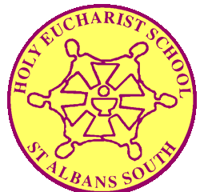
In Term 4 all students and teachers are required to wear a hat when they are outside. It is an expectation and school policy that all students wear their school hat and their correct school uniform at all times. If students are not wearing the correct uniform they are required to have a written letter from their parents explaining why they are out of uniform. Please note: If students are not wearing the correct school uniform, a note will be sent home informing the parent/guardian. This note will need to be signed by the parent/guardian and the name of the student will be recorded at the school office.
ASSESSMENT AND REPORTING – SEMESTER 2

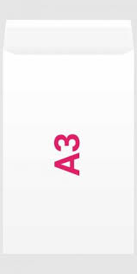
As was the case in Semester 1, 2020, student reporting in Semester 2, 2020 will look a little different to previous years. Reports will reflect adjustments that the school has made to curriculum programs in response to the needs and aspirations of the Holy Eucharist School community, and the disruption caused by COVID-19. The disruption to the school year has meant that there may have been less curriculum content covered than was initially planned. Despite all this, the teachers have endeavoured in making sure that the Semester 2, 2020 reports focus on the progress that has been made and on what has been achieved by each child.

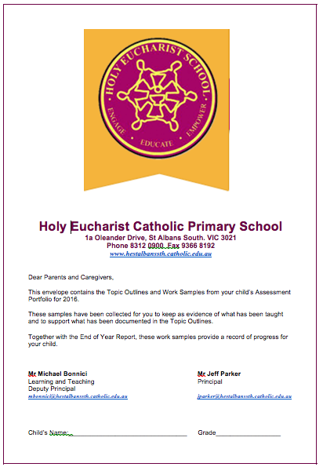
On Friday 4th December 2020 you will receive your child’s formal report together with the Student Assessment Portfolio. The work samples inside the portfolio are collected by the teacher as evidence of what has been taught during the term. These samples support what has been documented in the topic outline and should be looked at in conjunction with your child’s report.

Assessment Portfolios will need to be signed and returned to school by Wednesday 9th December. The classroom teacher will pass these folders onto next year’s teacher. All work samples collected during the year will be placed inside a Holy Eucharist Assessment envelope and given to you to keep.

SCHOOL PHOTOS

School photos will be taken on Monday 23rd November 2020. All students need to wear their full Summer Uniform and black school shoes.
SchoolPix want all students to have the opportunity to have a 2020 school photo taken. They have made a decision not to offer a traditional group photo for the remainder of the year. Instead they will take a portrait photo of each student and then create a “composite” group for each class using the portrait images. This will enable everyone to adhere to social distancing rules.
Please note that some parents have already paid for their photographs online in Term 1. If you are not sure if you have already paid, you can contact SchoolPix on 1300 766 055. If you need any more information, please feel free to contact Mr Bonnici.

PREP ENROLMENTS 2021
Just a reminder that Grade Prep enrolments for 2021 are almost full. If you wish to enrol your child for Prep next year, please do so as soon as possible. If you know of family friends who are also seeking a placement for their child, could you please let them know to contact the school office on 8312 0900.

CLASSES FOR 2021

This year our students have had lots of interruptions due to the restrictions and have not spent enough time together in their grades. It has taken a while for some students to re-adjust at school and to establish new friendships.
Seeing that our students have now settled back into routine, the staff thought that it would be a good idea to keep the existing class groups for 2021, instead of regrouping the students. This will mean that the students will move up to their new grade level as a group, the only difference is, that the students will have a new teacher. We are hoping that this process will enable our students to settle in more easily when returning next year.

M Bonnici – Learning and Teaching/Acting Principal

ORIENTATION DAY
Orientation Day will be held on Tuesday 1st December. The students at Holy Eucharist school will meet their new class teacher and fellow classmates for 2021 from 2:00pm until 2:50pm. Unfortunately due to the restrictions, our new Preps and all new families for 2021 will not be able to take part. The new preps will have their Orientation Day at the start of next year (More information to follow).

In order to accommodate Orientation Day the bell times (after midday) will need to be adjusted and will be as follows:

Grades Prep, 1 and 2 (Lunch) | Grades 3, 4, 5 and 6 (Recess)
12:35 Eating time  12:45 Lunch time  1:22 Toilet Bell  1:25 Session 3  1:55 Bell (2021 Teachers announced to the students)  2:00pm Orientation begins  2:50pm Orientation ends  3:00pm Home time – Junior School | 1:25 Recess  1:52 Toilet Bell  1:55 Bell (2021 Teachers announced to the students)  2:00pm Orientation begins  2:50pm Orientation ends  3:15pm Home time – Middle/Senior school

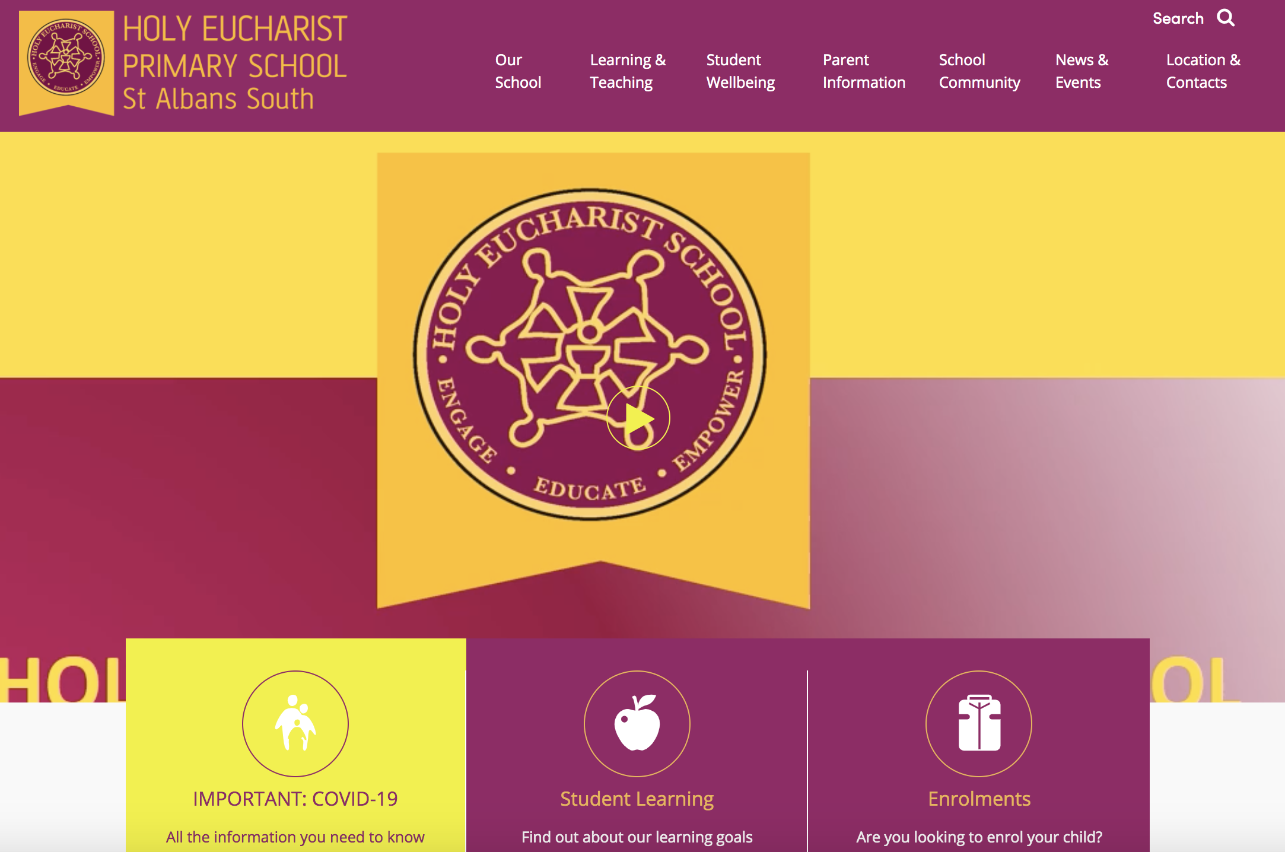
VIRTUAL TOUR OF HOLY EUCHARIST SCHOOL

During these uncertain times of COVID-19, school life has been interrupted. At the moment, it is not possible for families to see our amazing school. Therefore, we invite you to take a brief tour of our school by visiting our school website or by clicking on the following link https://www.hestalbanssth.catholic.edu.au/#home-video
Click on the arrow
We hope that this presentation will provide you with some insight into this vibrant school at a time when you cannot visit. If you would like further information, please call
our school office on 8312 0900 or please email principal@hestalbanssth.catholic.edu.au

Mr Michael Bonnici
Acting Principal/Learning and Teaching
Michael.Bonnici@hestalbanssth.catholic.edu.au

PREP STUDENTS 2021

Our Prep Transition Program is designed to help familiarise our future preps and parents with our school, meet the prep teachers and experience engaging and fun learning activities that will introduce them to the environment and the structure of school. These programs enable our students to familiarise themselves with their new school. However, due to the COVID-19 restrictions we have had to prepare alternative online sessions for our new prep children and parents. We have come up with this schedule for our new preps and their families.

- Story time and Song with Prep teachers 2021.

A Story Time and Song session will be conducted online via Zoom on Tuesday 24th November and Wednesday 25th November. Families will be sent information via email about the teacher who would run their story/games and songs session and the Zoom login details.

Prep Parent Information Session and Q&A Session via Zoom

Parent Information session will be on Thursday 19th November at 1:00 pm via zoom.

The Parent Information Session will cover topics such as:
General information about the school
Subject areas by the Curriculum leaders.

Time will be allocated for a Q&A session at the end.

The goal of the Parent Information Session presentation is to provide families with information about Holy Eucharist Primary School, prep curriculum and help answer questions that our parents may have.
We hope through this session all parents will benefit from the information shared and questions asked. Details for Parent Information Session will be emailed to families of our enrolled students in prep 2021.

- ZOOM Administration Session

Thursday 26th November. Time to be advised.

- Prep Teachers Kinder visits

Week Beginning: Monday 30th November, 2020.
Prep teachers will be visiting our kinder children in their kindergarten settings.
These visits will provide an opportunity for kinder teachers to discuss their educational program and the strategies they use to support the children’s learning. It will also provide prep teachers with the opportunity to observe and interact with children in the kindergarten learning environment to support the development of continuity between this and the school learning environment.
Children are often excited, and a bit daunted, by the experience of starting school. It is important to recognise that their expectations and experiences can impact on the success of transition from kinder to primary school. When children are given the opportunity to build positive relationships with prep teachers, they are likely to continue this positive engagement when they start school.
Providing time for children to interact with their prep teacher and build a relationship before starting school can reduce their anxiety and stress about starting school.
Cont.d

- Prep Meet and Greet the Teacher Drive Thru

Date for meet and greet the Teacher Drive thru is Thursday 3rd December.
Parents and children will be allocated a time between 12:30 pm – 2:00 pm to meet with Prep teachers via the drive thru.
It is important our students have the chance to make a personal connection with the Prep teachers. Teachers will meet and greet both you and your child, but will not be able to have a long conversation as the line may be backed up. Please remain in your car during the meet and greet. The children will receive a Holy Eucharist show bag. For parents, this will also be a time for the Administration Staff to connect with you, as you will be handed documentation regarding start/finish times for 2021, calendar for February, Fee commitment form and Parent Information Booket.

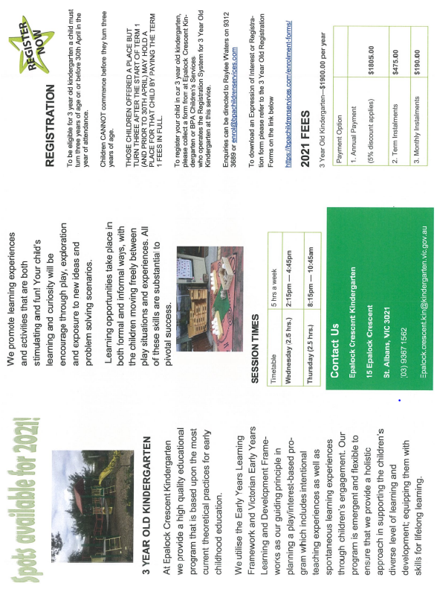
Entry to Meet and Greet the Teacher Drive Thru will be via the Holy Eucharist Church Driveway, Oleander Drive. Each family will be emailed an allocated time for the drive thru and a map for your convenience.

- Virtual School Tour

Come and have a look through Holy Eucharist Primary School. A video is available on the school website https://www.hestalbanssth.catholic.edu.au/ for parents to view, showing the highlights of our great school.

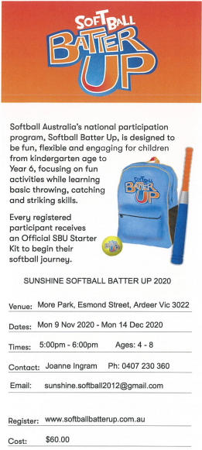

SAFETY OF CHILDREN AND ALL VULNERABLE PEOPLE
We hold the care, safety and wellbeing of children and all vulnerable people as a central and fundamental responsibility for our community. The Holy Eucharist Commitment to Child Safety and Reporting Process are on display in the Administration foyer of the School and School Policies are available on the website at www.hestalbanssth.catholic.edu.au

