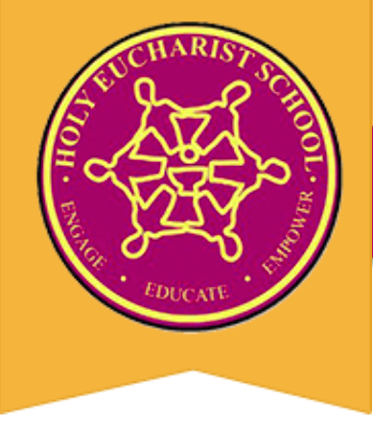
HOLY EUCHARIST SCHOOL
1a Oleander Drive, St Albans VIC 3021
PHONE: 8312 0900
www.hestalbanssth.catholic.edu.au

November/December 2020
CALENDAR | IMPORTANT DATES .
NOVEMBER
Sun 1st Nov -Feast of All Saints
Mon 2nd Nov -Feast of All Souls
Mon 2nd Nov -School Closure Day (Report Writing Day)
Tues 3rd Nov -Melbourne Cup (Public Holiday)
Thurs 5th Nov -Whole School Liturgy 9:20am
Thurs 5th Nov -Book Week Dress Up Day
Wed 11th Nov - Remembrance Day
Thurs 12th Nov - Whole School Assembly 9:20am
Thurs 13th Nov - World Kindness Day
Thurs 19th Nov - Whole School Liturgy 9:20am
Thurs 19th Nov - Pre Prep Family Info session
Sun 22nd Nov -Feast of Christ the King
Mon 23rd Nov -School Photos
Tues 24th Nov -Prep 2021 meetings via Zoom
Wed 25th Nov -Prep 2021 meetings via Zoom
Thurs 26th Nov - Pre Prep Family Info -Admin
Thurs 26th Nov - Whole School Liturgy 9:20am
Sun 29th Nov -1st Sunday of Advent
Mon 30th Nov -Kinder visits begin this week

DECEMBER
Tues 1st Dec - Orientation Day Gr 1-6
Thurs 3rd Dec - Meet & Greet Drive Thru- Prep 2021
Thurs 3rd Dec - Whole School Liturgy 9:20am
Fri 4th Dec - Grade 6 Graduation
Fri 4th Dec - Reports & Portfolios go home
Sun 6th Dec -2nd Sunday of Advent
Tues 8th Dec - Feast of Immaculate Conception
Tues 8th Dec -Gr 6 Graduation Liturgy
Wed 9th Dec -Portfolios due back at school
Thurs 10th Dec - Whole School Liturgy 9:20a
Thurs 10th Dec -Human Rights Day
Sun 13rd Dec -3rd Sunday of Advent
Tues 15th Dec -Last day of school- students finish at 2pm
Tues 15th Dec -Whole School Liturgy

Sunday | Monday | Tuesday | Wednesday | Thursday | Friday | Saturday
FEAST OF ALL SAINTS 1 | FEAST OF ALL SOULS 2  School Closure Day | 3  Melbourne Cup  Public Holiday | 4 | 5  Whole School Liturgy 9:20am  Book Week Dress Up Day & Assembly 9:30am | 6 | 7
32nd Sun Ordinary Time 8  YEAR A | 9 | 10 | 11  Remembrance Day | 12  Whole School Assembly 9:20am | 13  World Kindness Day | 14
33rd Sun Ordinary Time 15  YEAR A | 16 | 17 | 18 | 19  Whole School Liturgy 9:20am  Parent Information Session for Pre-Prep Families- Zoom 1:00pm | 20 | 21
FEAST OF CHRIST THE KING 22 | 23  School Photos: Students wear full summer uniform | 24  Prep Teachers meeting with Preps 2021 via Zoom | 25  Prep Teachers meeting with Preps 2021 via Zoom | 26  Whole School Liturgy 9:20am  Administration Parent Information for Pre-Prep Families - Zoom | 27 | 28
1st SUNDAY OF ADVENT 29  YEAR B | 30  Kinder Visits begin this week | DECEMBER 1  Orientation Day for existing students: Grades 1- 6 | 2 | 3  Whole School Liturgy 9:20am  Meet & Greet Drive Thru for Pre Preps | 4  Grade 6 Graduation Day  Reports & portfolios go home. | 5
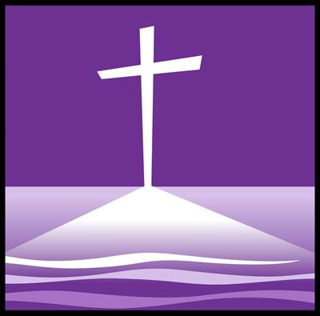  2nd SUNDAY OF ADVENT 6  YEAR B | 7 | 8  FEAST OF THE IMMACULATE CONCEPTION OF MARY  Grade 6 Liturgy & Graduation Ceremony via Zoom at 6pm | 9  Portfolios Due back at school | 10  Whole School Liturgy 9:20am - 3rd Sunday of Advent  Human Rights Day | 11 | 12
3rd SUNDAY OF ADVENT 13  YEAR B | 14 | 15  Last Day of School for 2020: 2pm finish  Whole School Liturgy 9:20am | 16 | 17 | 18 | 19

