HOLY EUCHARIST SCHOOL COMMUNITY HUB TIMETABLE
TERM 1/ 2024
MONDAY | TUESDAY | WEDNESDAY | THURSDAY | FRIDAY
9am - 10.30am  Playgroup  (All age groups are welcomed)  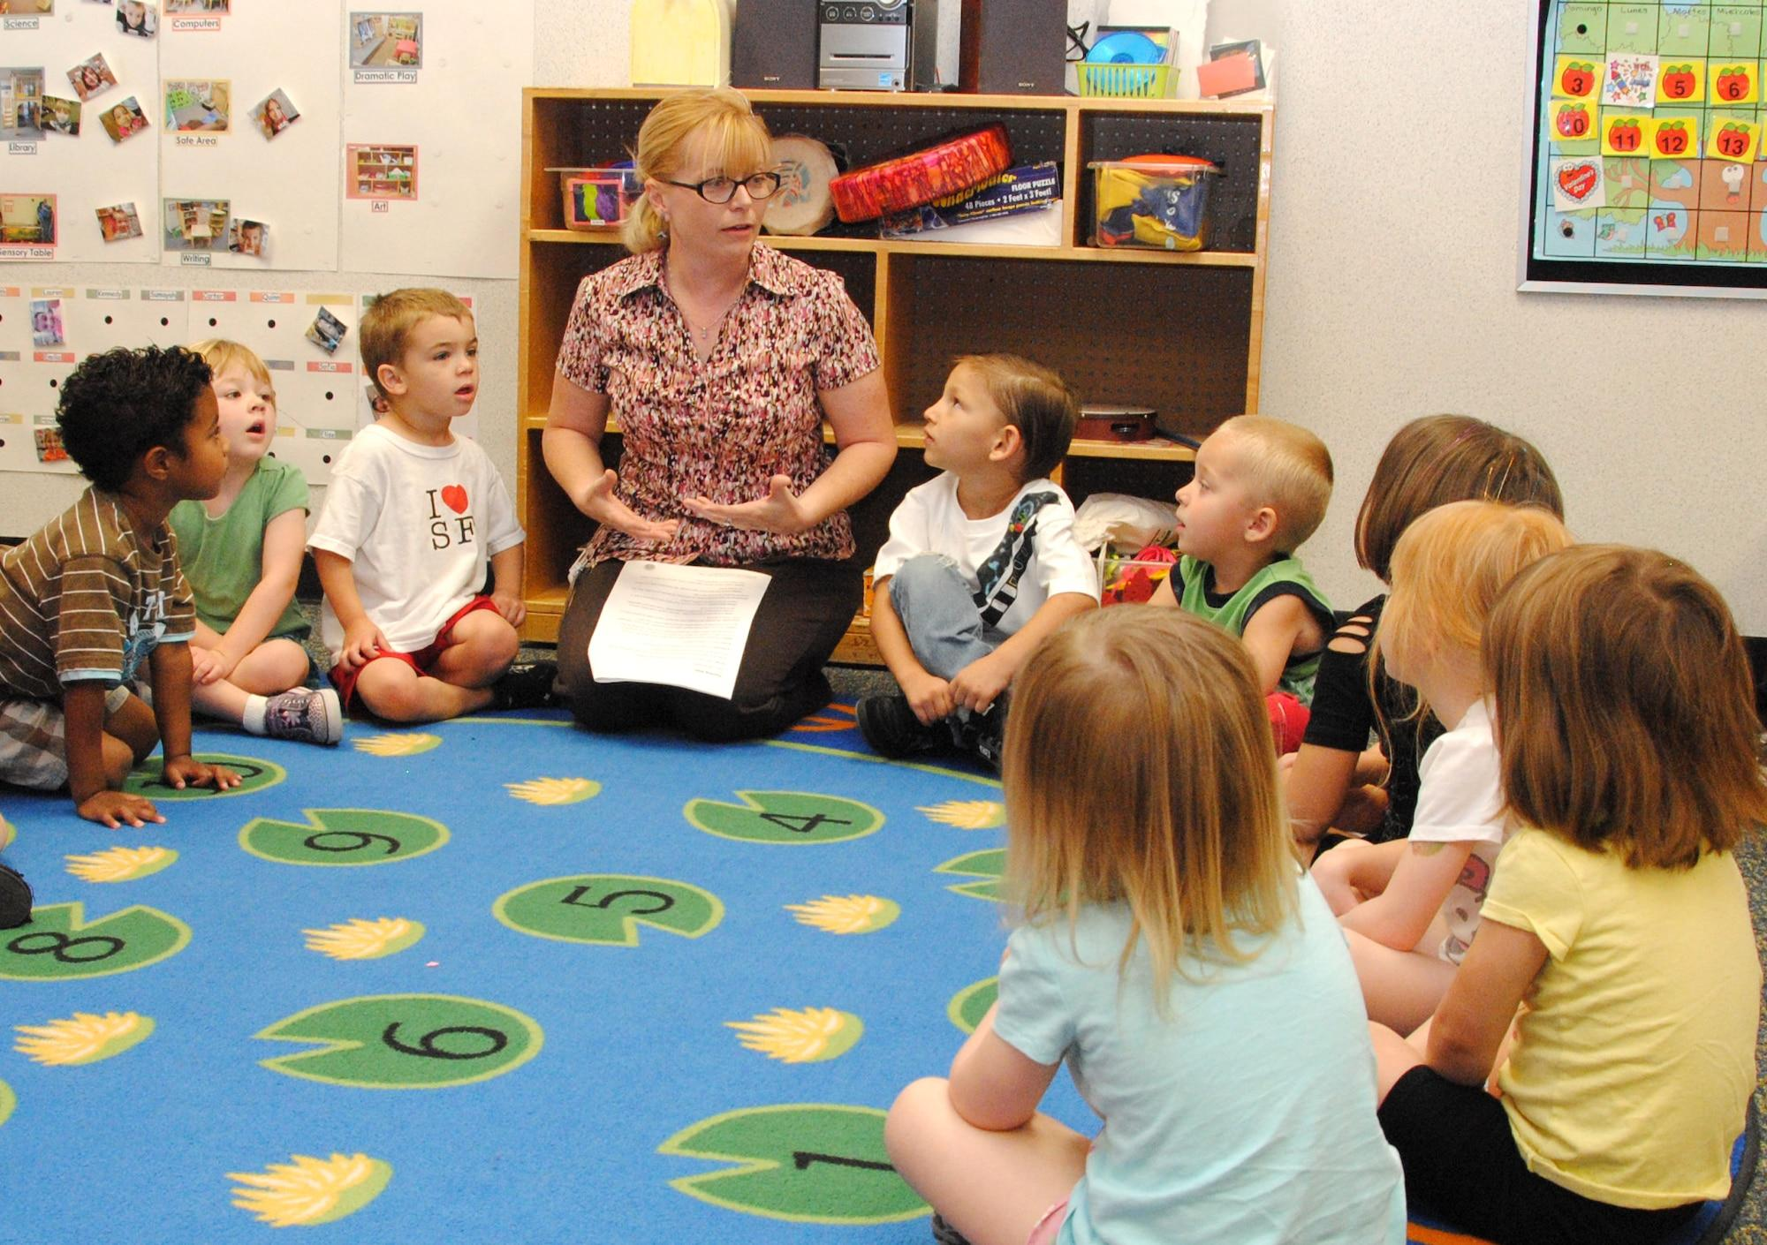  2pm-2.45pm  Zumba: Dance it all with Fela  2.45pm-3.15pm  Meet and greet families in the yard | 9:30am - 2.30pm  Parent & Child English program  3.15pm-4.15pm  Homework club  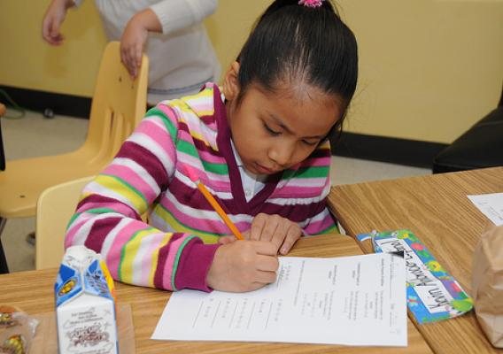 | 9:30am – 11am  Zumba Fitness Class  12pm onwards  Assistance filling out paperwork | 9am - 3.00pm  Certificate III in Early Childhood Education course  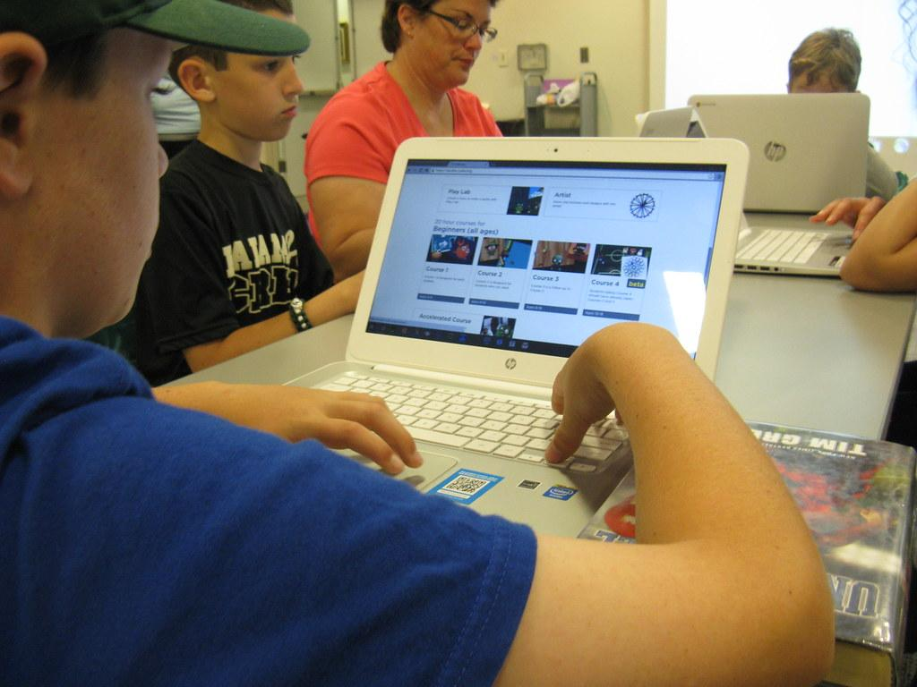 | 9:30am – 11am  Craft & Conversation (Week A)  OR  Cooking Class (Week B)  on alternate Fridays  12pm onwards  Hub data entries

ALL HUB ACTIVITIES ARE FREE
Hub Leader: Van Nguyen
van.nguyen@hestalbanssth.catholic.edu.au
Contact Number: 03 8312 0900
0417 112 893

